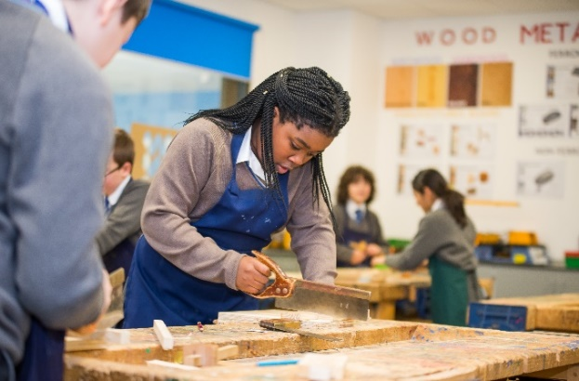

Assessment at SJBC


How often are you assessed?

Assessment cycles
Each pupil in Key Stage 3 and 4 will be assessed during three assesment cycles with one taking place each term. Assessments will follow the same protocols as those in final GCSE examinations at the end of yr11. Pupils will take subject exams known as Pre- Public Exams (PPEs) over the course of a week in exam conditions in the main hall. This process helps ready them for their external exams at the end of key stage 4 by providing a sense of familiarity with the formal regulations experienced in public examinations.

Quintile Example
Name | % | Quintile
Jo | 90 | 1st
Billy | 89 | 1st
Jim | 84 | 2nd
Bob | 76 | 2nd
Dave | 67 | 3rd
Claire | 53 | 3rd
Mike | 46 | 4th
Susan | 22 | 4th
Jane | 11 | 5th
Kelly | 9 | 5th

Key stage 3 (yr7&8)
Teachers mark each exam and award a percentage. Once all pupils have been awarded a percentage they are then ranked against everyone else in their year group. All pupils are then split into a relevant ‘quintile’ as shown in the example on the left. In this example, where there are only 10 pupils, each quintile is populated by 2 pupils. The 1st quintile reflects those pupils who have achieved the highest scores, working down sequentially to the 5th quintile for pupils who achieved the lowest scores. Both Years 7 and 8 contain a little over 100 pupils and so in the real world each quintile would be populated by just over 20 pupils. Each report will identify the quintile your son/daughter has reached for each of their subjects. The final column on the report then shows the average quintile for all the subjects combined. Additionally we have taken all pupils’ Key Stage 2 scores (that were achieved at the end of yr6), ranked these and place all pupils into a quintile according to these. This helps to give a measure of context to pupils’ performance. If, for example, a pupil sits in the 5th quintile for their Key Stage 2 scores but has acheieved predominately 4th quintile results in their exams then this indicates positive progress and should be viewed as such.
Key stage 4 (yr9,10&11)
As in Key Stage 3 pupils sit exams in all of their subjects with these being marked by their teachers. Pupils will then receive a grade 9-1, with 9 being the highest and 1 being the lowest. A grade 4 is considered as a standard pass, with a grade 5 being considered as a strong pass. Pupils who do not achieve at least a grade 4 in English and Maths are required, by law to continue with these after year 11. Pupils are graded accurately in line with the exam that they sit during that assessment cycle and it is important to remember that progress is not linear. Some pupils will perform well during one cycle and then appear to regress at the next, this may mean that they are struggling with the partcilaur concepts involved in that exam. Through regular formal exams we can then narrow teaching and intervention to address specific weaknesses of pupils in particular subjects. Additionally it is expected that yr9 pupils, who are at the beginning of their GCSE courses, will generally peform lower down the 9-1 scale than those in yr11. This is because the grading reflects their current level not their expected level at the end of yr11. Pupils are encouraged to think about their Post-16 options as early as possible and ensure that they are working at the grade level required to access these.

Regular Low Stakes Testing and Homework
Pupils in yr7-11 follow the same policy of regular low-stakes testing and a preparation-centered homework model. In practice this means that pupils can expect to be tested, within lessons, every 2/3 weeks. These assessments may last the duration of a lesson or form only a small section within the lesson, they are collected and stored by class teachers in assessment folders (which will serve as useful revision aids for pupils later on) and recorded on the ‘Show My Homework’ app so that parents can track pupil progress between assessment cycles. Frequent low-stakes testing allows teachers to address misconceptions as they arise and ensure that pupils are given the best opportunity to succeed in the formal PPEs. Our homework policy is designed to support pupils with structured revision topics leading up to each assessment cycle. Departments will identify the topics included in each exam on ‘Show My Homework’ and direct pupils to independently prepare revision materials for these assessments. By establishing good study routines across the school the aim is to develop pupils’ skills from year 7 so that they can tackle large public exams with confidence. The school will run supporting sessions throughout the year embedding these study skills to all pupils, parents can support by following their progress on ‘show my homeowrk’ and by creating a an effective study environment at home..

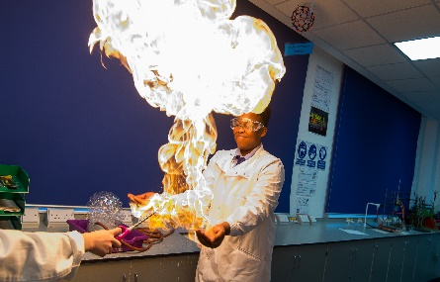

Key stage 5 (yr12&13)
As in lower school pupils sit exams in their chosen subjects with these being marked internally. Teachers mark each exam and award a fine grade. This means that a high end grade B will appear as B1, an average grade B as B2 and a low end grade B as B3. This is to indicate how close or far the pupil is from progressing to the next grade. Reports are sent home termly and will include PPE grades alongside predicted grades so that parents can see how their child is progressing in each course.
At Key Stage 5 we use ALPS. This analytical tool gives staff, pupils and parents a visual representation of progress. ALPS uses a themometor grading system to show performance of each pupil against national benchmarks.

1-3 red = top 25%
4-6 black = middle 50%
7-9 blue = bottom 25%

Pupils are encouraged to take ownership of their learning and monitor their own progress on the ALPS ‘war’ board displayed in the sixth form study area.
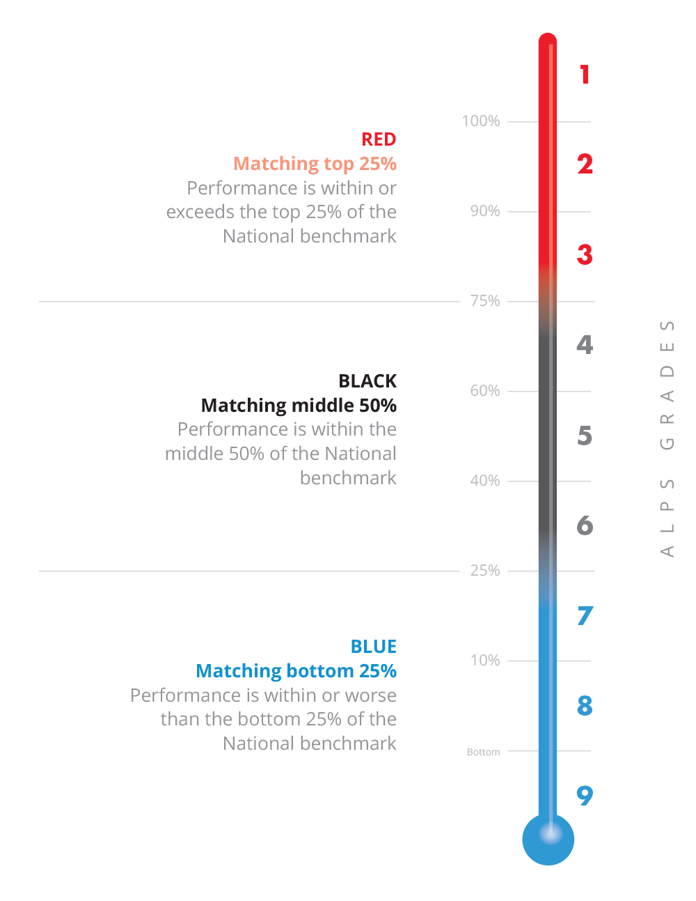



How YOU can help your child do well at school
Parental support is 8 times more important in determining a child’s academic success than any other factor. The Campaign for Learning found that parental involvement in a child’s education can mean the difference between success and disappointment at GCSE and A Level.
The good news is that you don’t need to be an expert in any of the subjects your child chooses to make a real difference. You also don’t need to give up your life and other responsibilities – you just need to know how best to spend the time you do have. One of the hardest demands on students is that of understanding the long-term importance of doing the best they can, and learning to shelve short-term fun at times in the interest of long-term benefits (not easy even for adults). Children will also differ in their levels of maturity, their ability to take responsibility for their learning, organisational skills and levels of motivation. This is where parents come in. Your support, encouragement and interest can make a spectacular difference to your child’s motivation and ability to cope with the academic and organisational demands of learning.
At St John Bosco College we have done a lot of research into how students learn best and thus the school calendar is built around three main exam assessment periods every year and regular homework that is teacher led structured revision leading to 2-3 weekly tests in all subjects. This encourages students to learn regularly in small chunks to help memory and embedding of knowledge. You can read the school’s full homework policy and recommended times of home study for each year group on our website.
Make sure your child has a place to study at home, resources they need (for example revision cards they can use, highlighters and books from school) and that you have a calendar/timetable up in their bedroom and somewhere central like the kitchen which gives a clear structure to what they should do each night – agree this together as soon as possible. Make sure that they have clear periods for study and time for breaks and enjoyment. Make sure you maintain regular sleep routines for them and that they have a healthy diet to help them concentrate and learn.

To help you support your child at home the following is in place for parents at SJBC:
- Test dates and revision materials for all subjects are uploaded onto Show My Homework. Log into their app with your personalised PIN (available from school reception) to track your child’s grades. Talk to your child about upcoming tests and the materials they need to cover – you can stay one step ahead yourself by looking through what teachers have uploaded on Show My Homework before you talk to your child. Make sure your child knows that you are interested and tracking their progress in their regular tests: praise them for good results and improvements and talk through what went wrong if results are disappointing.
- Go into the Learning/Curriculum Offer section of the website. Here you will find termly plans for each subject area for each half term with links to specific resources to help develop a child’s revision and extended learning. You can use these to be clear about what your son/daughter is learning in any half term period and to help them study in a targeted way at home.
- Ask for help when needed. If you are worried or need further information the teachers are here to help. Email addresses for all Heads of Department, Form Tutors and Heads of year are on the webpage. No matter how little – just ask! Make sure you attend all parent information evenings and when you can also PTA meetings as this gives an opportunity for you to find out what is happening at school and meet other parents who face the same challenges as you.
- More ideas for parents are available here: http://www.bbc.co.uk/schools/parents/helping_with_exams/ or in the parents’ section of the school website.

