



St John Bosco College

Pupil Premium 2017/18








Contents

Pupil Premium ‘the facts’…………………………………………………….…………… page 3
Ofsted and the Pupil Premium…………………………………………………………. page 4
Pupil Premium at St John Bosco College……………………….…………………… page 4
Review of spending 2015/2016………………………………………………………... page 6
Summary information…………………………………………………………….…………page 11
Barriers to future achievement at SJBC……………………………………………... page 12
Strategies poster……………………………………………………………………………… page 14
Future outcomes……………………………………………………………………………… page 15
Planned expenditure…………………………………………….………………………….. page 16

Pupil Premium: the facts
Introduced in April 2011, the pupil premium is allocated to children who are looked after by the local authority, those who have been eligible for FSM at any point in the last six years and for children whose parents are currently serving in the armed forces. The level of premium for 2017-18 varies between £935 and £1,900 per pupil depending on their exact classification. As of April 2014 children who are looked after will attract a higher rate of funding than children from low-income families - the ‘Pupil Premium Plus’, which will be £1,900 per pupil for 2017-18. This is to reflect the unique challenges they face at school where they often struggle to keep up with their peers at both primary and secondary level.
Funding levels 2018/18:
- Ever 6 FSM TFE £935 per pupil per year
- LAC £1900 per pupil per year
- Ever 6Service child £300 per pupil per year
Attainment gaps between pupils from deprived backgrounds and their more affluent peers persist through all stages of education, including entry into higher education. The highest early achievers from deprived backgrounds are overtaken by lower achieving children from advantaged backgrounds by age seven. The gap widens further during secondary education and persists into higher education. The likelihood of a pupil eligible for FSM achieving five or more GCSEs at A*-C including English and mathematics is less than one third of a non-FSM pupil. A pupil from a non-deprived background is more than twice as likely to go on to study at university as their deprived peer.

Accountability
Individual schools decide how the pupil premium allocated to them is spent. Schools are accountable for their use of the additional funding to support pupils from low-income families and the impact this has on educational attainment. Since September 2012, schools have had to publish online details of their pupil premium allocation and their plans to spend it in the current year. This documents sets out our Pupil Premium allocation and how we intend to make use of it for the benefit of our pupils.

Ofsted and Pupil Premium
In September 2012 Ofsted published the results of a survey it carried out to identify how schools were using this money to raise achievement and improve outcomes for pupils. Recommendations for schools from the survey include:
- School leaders, including governing bodies, should ensure that pupil premium funding is not simply absorbed into mainstream budgets but instead is carefully targeted at the designated children. They should be able to identify clearly how the money is being spent.
- School leaders, including governing bodies, should evaluate their pupil premium spending, avoid spending it on activities that have little impact on achievement for their disadvantaged pupils, and spend it in ways known to be most effective.
- Schools should continue to seek ways to encourage parents and careers to apply for free school meals where pride, stigma or changing circumstances act as barriers to its take-up

Pupil Premium at St John Bosco College
The Pupil Premium is used at St John Bosco College to provide a range of intervention activities, improvement strategies, staff and staff time that ensures direct support for students who are entitled to Pupil Premium funding so that they thrive and succeed. The funding is discussed as part of the annual budget-setting process and the priorities are determined by the individual and group needs of students entitled to the funding. The provision and spending of the Pupil Premium fund is regularly monitored and analysed by SLT and Middle Leaders to ensure there are continued positive outcomes for students. Ineffective practices are removed and replaced with new strategies to ensure we are proactive and at the forefront of best practice with our spending in the removal of barriers to learning. The details of how the previous years spend and the planned expenditure for this year are outlined in detail over the follow pages.

Pupil Premium Outcomes at St John Bosco College
 | 2016/17 |  | 2017/18
 | All Students | Disadvantaged | All Students | Disadvantaged
Progress 8 | -0.2 | -0.6 | 0.03 | -0.40
Low | 0.61 | 0.07 | 0.84
Medium | -0.24 | -0.45 | -0.18
High | -0.42 | -1.54 | 0.04
English | -0.2 | -0.4 | -0.05 | -0.35
Maths | -0.4 | -0.7 | -0.40 | -0.65
EBACC | -0.1 | -0.6 | 0.55 | -0.03
Open | -0.1 | -0.6 | -0.14 | -0.65

The table here details the outcomes of all and PP students in years 2015/16 and 2016/17.

Pupil Premium 2016/17 Expenditure Review
Review of expenditure 2016/17
Whole school development plan
Desired outcome | Impact | Lessons learnt | Continue?
Progress of PP pupils at key stage 3 and 4  Weekly meetings to discuss focus students and shared intervention strategies between departments. | Gap between pupils PP and no PP pupils remains at 0.40 however improvement of 0.20 on previous years results for groups indicates strong progress in improving attainment is being made by all. | Improved progress of PP pupils demonstrating successful interventions. Where impact is high these will continue this year, where improvements can be made this will be identified. | Yes
Additional Maths and English intervention, 1:3 tutoring | 1:3 tutoring supported most of our PP pupils in improving progress on previous year. Both English and Maths PP results improved by 0.05. On Average those students who received tutoring improved their grade by 0.5 compared to those who did not. | 1:3 tutoring showing significant improvements in core subjects. Progress seen on previous year, gap in English between PP and non PP has widened. Tutoring programmes to begin earlier with a focus on English. | Yes
Address behaviour in Year 10 | Oliver Dunn project with identified year 10 students led to a reduction in the volume of exclusions amongst this group of pupils. Year 10 behavior for the academic year was 625 demerits compared to 854 the previous year. | Behavior across the school continues to improve. The percentage volume attributed to PP pupils has decreased from 63% to 59%. The personalized approach to improving behavior amongst specific groups of pupils appears successful. | Yes
Improving pupil engagement, aspirations and behavior | Volume of high quality teaching rose steadily throughout the year. Student questionnaires completed regularly to gauge their views on school life. Several workshops ran aimed at improve students meta-cognitive skills and aspiration’s to higher education. | Percentage of PP demerits fell from 63% to 59% between 2015/16-2016/17. Continue behavior interventions and supplement with PP specific programs such as Jamies Farm. | Yes
Increased attendance rates | Attendance rates improved from 205/16 to 2016/17. Last year PP students attendance was even higher than non Pp with 93.79% improving to 94.59%. | Impact of EWO escalating all incidences of attendance below 90% showing significant improvements. Designated ‘attendance lead’ (UPS Project) picking up pupils within the 90-95% group. High impact in terms of outcomes as a result of improved attendance. | Yes
Improved accuracy of predictions at key stage 4 | External set PPE’s moderation between groups of schools allowed for more accurate predicting of student outcomes. Predictions were more accurate than previous year. English and Maths used PiXL as part of their moderation process. | Predictions were in line with outcomes, this allowed greater intervention in the areas were improvement was required the most.  The core subjects will continue to receive PiXL support for moderation this year due to the new examination courses. Where offered from PiXl this will spread across other subjects. | Yes
Restorative Justice programme  Circle time training for staff | Focusing on increasing student engagement by allowing pupils to share their views when things have gone wrong. Large number of staff now trained to support this effective process. | Effective conflict resolution and reintegration through a system that ensure pupil removal from lesson is RJ’d before issues can build between students and teachers. Evidence seen through reduced exclusion rates. | Yes
Improved parental engagement and communication | Communication log. Volume of use has increase dramatically since its implementation. Evidence of previous conversations and interventions in place. School PTA now re-formed and up and running. | PTA group has now expanded to 12 regular members. Their feedback and support has helped advise school policies moving forward. | Yes
Careers advice and guidance | Drop down careers day for each year group has improved pupil understanding of the role of education and aspiration leading to improved behavior | Well planned and effective days have resulted in improved performance and attitudes, as demonstrated through the behavior log and demerits. | Yes
Year 7 transition coordinator | Been in post since September 2016. Helping to develop the transition process from key stage 2 to 3. | Year 7 pupils arrive at school more familiar with the building and staff. Usual ‘transition’ period reduced, focus on learning earlier as a result. | Yes
Counseling | Counselling in place for all pupils who need it. Highest percentage of pupils receiving this are PP than non PP. Takes place 4 days a week. 16 students seen for a block each half term. | Essential part of our delivery of ethos and support to both PP and non PP pupils. Feedback from pupils is really positive, they value this service. | Yes
Maths training for non specialist teachers and teaching assistants | TA’s teaching small groups seen a raise in grades for Maths at key stage 3 and 4. | Small group work in Maths has shown to be very effective and increased coordination of this with PP pupils is recommended. Impact is high. | Yes
Improved Literacy and Developed Reading Strategies (KS3) | The accelerated reader programme has seen ‘expected progress’ across all pupils. This boost to our PP pupils is significant in terms of increasing their ability to access the curriculum. | No significant difference between PP and non PP progress. Programme now reduced to only year 7 and 8 where impact is greatest. | Yes
Differentiation for PP students | A PP strategy poster (found in this booklet) has been distributed to work areas around the school. Staff observations focus on progress of all pupils with reference to differentiation strategies. | Teaching and progress across both PP and non PP pupils is generally positive. Most subjects at key stage 3 demonstrate PP differentiation. Awareness of these groups and continued training to support moving forwards. | Yes
Improved marking and feedback | Book scrutiny has focused on at least 1 PP book in each round. This increased focus has ensure staff are prioritizing PP marking. Developed short notice system has increased the volume of Pp books looked at and the recording of these reviews. | Marking across the school is generally good. New SIMS systems allows quick review of areas of strength and weakness. Continual focused feedback to staff will continue to ensure improvements take place. | Yes
Homework monitoring | Show my homework software purchased that allows rigorous monitoring of homework set. Setting of homework is currently good. Last year saw a decrease in homework demerits from 1618 to 1337. | Ongoing monitoring of volume set by ‘homework lead’ (UPS project) ensuring consistency across the school. Focus should now shift to the mark book facility within this program. | Yes
Raised awareness and identification of PP pupils | Regular sharing of PP lists including banding. SIMS updated to show. Additional efforts to encourage parents to register. | Dedicated staff training required. Morning briefings have improved teacher awareness. | Yes
Revision workshops for key stage 4 | Speakers brought into school to deliver revision based sessions targeted at key stage 4 and 5 | Very effective, feedback from staff and pupils very supportive | Yes
Financial support for attending trips and visits | Ensures fair access to all educational trips/visits that may come with an attached cost | Over the course of the year no support was requested. This year has seen 2 requests already demonstrating the profile of PP support has increased. These will be reviewed on a case by case basis. | Case by case basis

Summary Information
School | St John Bosco College
Academic year | 2017/18 | Total PP budget | £189,170 | Date of most recent review | Sep 2017
Total number of pupils | 529 | % of pupils eligible | 46% | Date for next review | Feb 2018

Group | Students on roll | Pupil premium | Pupil premium %
Year 7 | 109 | 62 | 57%
Year 8 | 92 | 49 | 53%
Year 9 | 107 | 51 | 48%
Year 10 | 48 | 21 | 44%
Year 11 | 68 | 33 | 49%
Year 12 | 70 | 27 | 39%
Year 13 | 35 | 0 | 0%
Total | 529

Attainment 2017 (76 pupils total with 33 PP pupils)
 | SJBC Total | SJBC PP pupils | National
Attainment 8 Average Score | 43.83 | 37.23
% Achieved a standard pass in Eng & Maths | 47% | 36%
Achieving the English Baccalaureate | 13.63 | 11.14
Progress 8 score | 0.03 | -0.40

Barriers to future attainment
In-school barriers
A. | Literacy skills entering year 7 are lower for pupils eligible for PP than for other pupils, which prevents them from making good progress in key stage 3. Reading scores from key stage 2 are below the national average in 2017
B. | Mathematical skills entering year 7 are lower for pupils eligible for PP than for other pupils. The percentage of students meeting the expected national average in 2017
C. | High attaining pupils who are eligible for PP are making less progress than other high attaining pupils across key stage 3 and key stage 4. This prevents high achievement and attainment at key stage 4
D. | Progress of disadvantaged students in key stage 4 English is lower than the national average and in key stage 4 Math’s is lower than the national average
E. | Motivation of disadvantaged students in Key Stage 4 is an issue which can lead to poor levels of progress and attainment
F. | Staff awareness of PP student barriers and progress tracking is in need of development
External barriers
G. | Attendance rates for pupils eligible for PP are below the target of 95% for all children. This reduces their school hours and causes them to fall behind
H. | Parental engagement, aspirations and opportunities of disadvantaged pupils can be lower than non-disadvantaged pupils.

The above table describes the barriers that must be overcome in order to improve the progress and attainment of PP pupils at St John Bosco College. The importance of understanding these challenges and sharing these with staff crucial in the schools efforts to narrow the gap between disadvantaged and non-disadvantaged pupils.

The ‘Strategies Poster’ on the following page should be displayed around the school in staff areas and used a quick reference guide for staff when planning lessons.

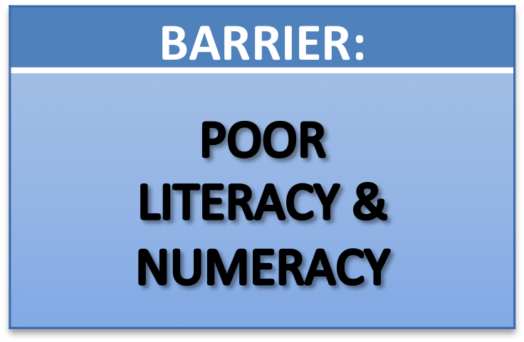
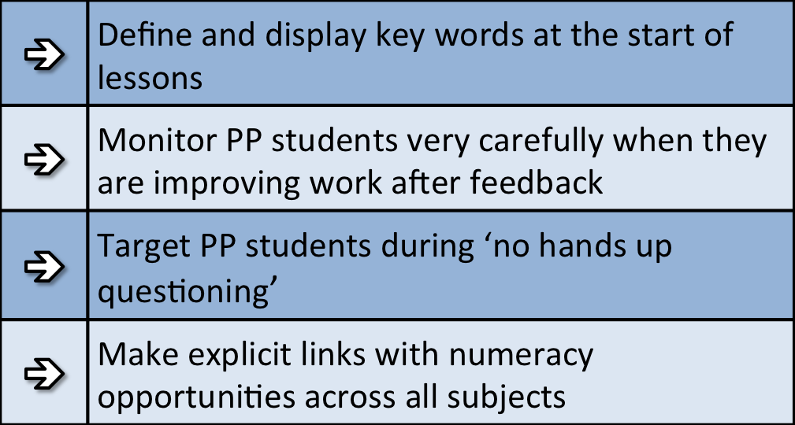
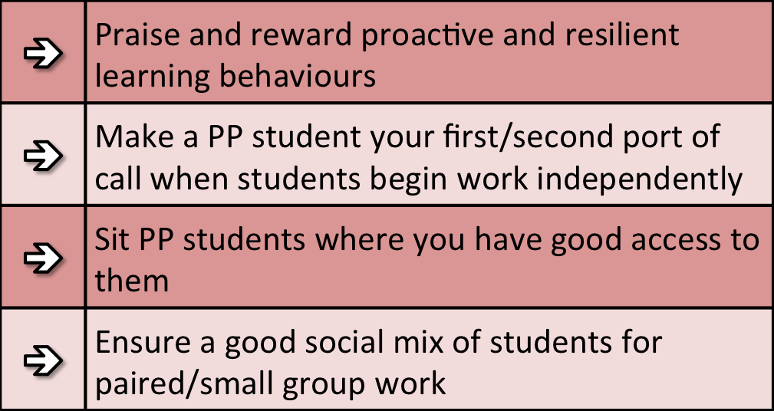
Strategies to promote Pupil Premium Students’ learning



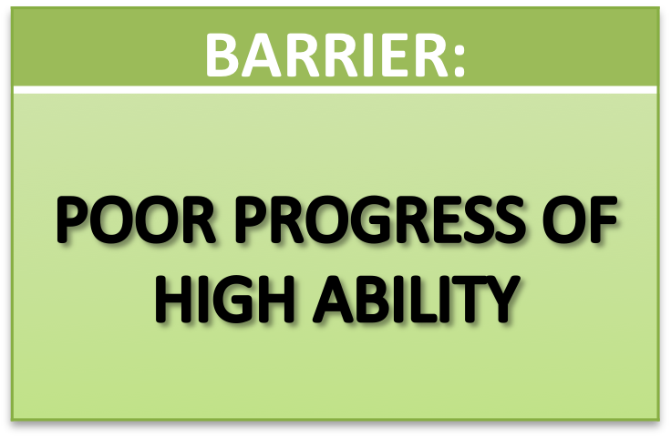
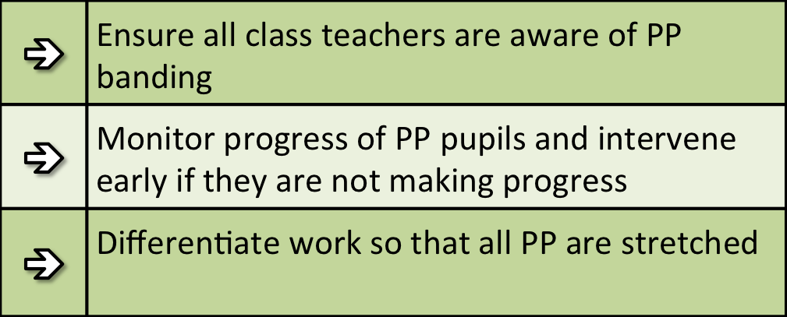

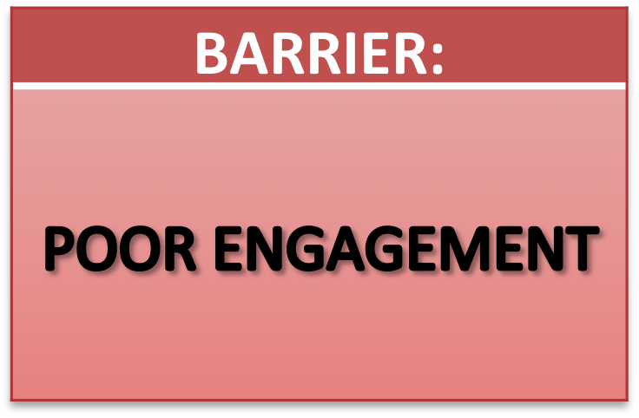

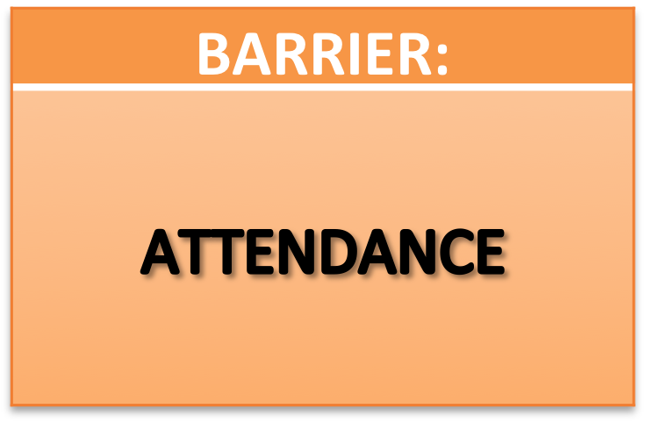



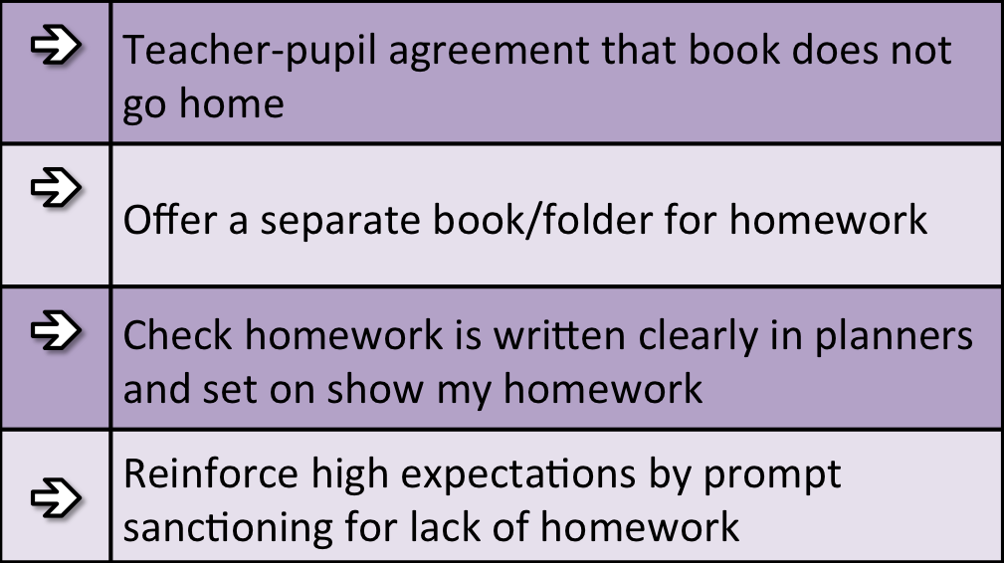
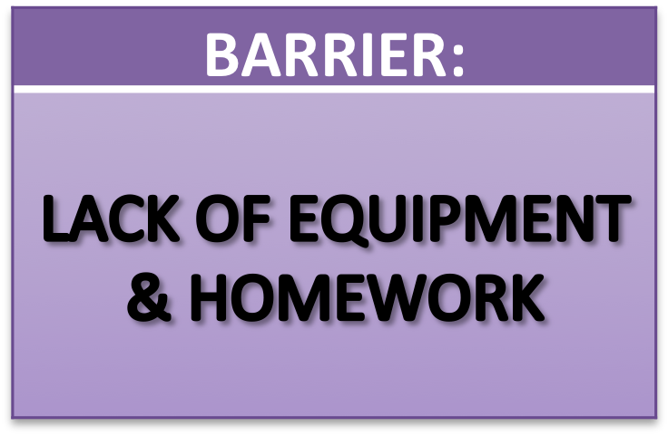

Future Outcomes
 | Desired outcome and how they will be measured | Success criteria
A. | High levels of progress in literacy for year 7 pupils eligible for PP | Pupils eligible for PP in year 7 make more progress than expected narrowing the gap between them and ‘other’ pupils. This will be evidenced by using accelerated reader assessments from the key stage 3 literacy programme
B. | High levels of progress in numeracy for year 7 pupils eligible for PP | Pupils eligible for PP in year 7 make more than expected progress narrowing the gap between them and ‘other’ pupils. This will be evidenced by key stage 3 Maths assessments at the end of each term
C. | Improved rates of progress across key stage 3 and 4 for high attaining pupils eligible for PP | Pupils eligible for PP identified as high attaining from KS2 SATS / raw scores make as much progress as ‘other’ pupils identified as high attaining, across Key Stage 3. Where they are not, departments are putting in place interventions, monitored by heads of departments (HOD) and senior team following progress reviews.
D. | Improved progress of disadvantaged pupils in English and Maths by the end of key stage 4 | Improve the P8 score of disadvantaged students in English and Maths so it is closing the gap on non-disadvantaged. Successful intervention program established including 1-3 tuition. Evidenced by improved outcomes
E. | Increased levels of motivation which has a direct impact on attainment and progress | Successful mentoring scheme established which in turn increases the progress 8 score of disadvantaged students and closes the gap on non-disadvantaged students. Evidenced by improved outcomes and lower rates of recorded poor behaviour
F. | Increased staff awareness of PP barriers and strategies used to overcome | Staff data monitoring progress of PP students demonstrating progress. Observations identify good practice and staff CPD. Evidenced by staff confidence in line management and observations
G. | Increased attendance rates for pupils eligible for PP | Overall attendance among pupils eligible for PP improves to above non-PP national average
H. | Increased parental engagement, aspirations and opportunities of pupils eligible for PP | Parents evening attendance improved for PP students. Projects implemented to increase the aspirations of PP pupils and the range of additional opportunities opened up to PP pupils.

Planned Expenditure 2017-18
Desired outcome | Chosen approach | Rationale | Staff lead | Cost
Progress of PP pupils at key stage 3 and 4  Barriers A, B, C & D | Year leaders to monitor PP progress / outcomes post Progress Reviews. | Outcomes: Year Leaders to monitor progress of PP students in Core subjects and liaise with students, parents and teachers in creating individualised learning plans.  DfE guidance stated that successful schools use ‘learning plans’ to bring about improvements in outcomes. | HoY  SLT | £1000
Additional Maths and English intervention  Barriers C & D | Additional English support, 1:3 tutoring  Additional Maths support, 1:3 tutoring | DfE guidance students on successful schools has stated that those who were most successful had a programme of ‘removal from lessons to offer tailored support to students.’ The funding of tutors for English and Maths teaching groups of 3 during and after school to boost outcomes in the core subjects. | TRD  MHY  KUN | £10,000
Address behavior and engagement concerns in Year 10  Barrier E | Jamie’s Farm residential trip.  Rigorous analysis of data to measure impact and effectiveness of trip. | The EEF Toolkit suggests that targeted interventions matched to specific students with particular needs or behavioural issues can be effective, especially for older pupils.  Ensure identification of pupils is fair, transparent and properly recorded.  Evidence from Jamie’s farm indicates significant progress of those students who attend. | JBD  SEI | £6000
Improving pupil engagement, aspirations and behavior  Barriers E & H | Partnerships with outside agencies and alternative provision  London Fire course  Fixed term alternative provision | Students that have been identified, including PP students, who would benefit from attending alternative provision to allow them to develop skills beyond the normal school curriculum  Each academic year we select students who would benefit from being out of the normal school setting and provide them with opportunities to attend external providers such as the London Fire Course to enhance their life skills to ensure they are prepared for the next step in their education  Where absolutely necessary alternative provision can be provided at one of our partners when a pupil needs to be removed from mainstream setting for a short period of time. At these partners they continue to work in line with our curriculum and progress is unaffected | SOK  MBA | £500
Increased attendance rates  Barrier G | Employment of a School Attendance Officer and support  Use of data to analyze PP students who are PA  Improved communication with PP parents  Analysis of ‘lates’ data to identify PP students | The Attendance Officer is responsible for the day to day tracking of attendance and punctuality. They are the first contact with home and build relationships with parents to improve attendance NfER briefing for school leaders identifies addressing attendance as a key step.  The Attendance Officer works closely with Heads of Year and SLT to monitor and improve attendance. They monitor PP students and PA PP students weekly.  DfE guidance on successful schools stated that ‘Regular attendance was a priority in more successful schools, with the importance of this being shared with all pupils and families.’ In addition, Attendance at school is also related to performance, with higher attendance rates associated with higher attainment (Taylor, 2012). DfE also found that ‘Schools with higher levels of pupil absence had lower performance among PP pupils than schools with otherwise similar characteristics’ and ‘higher levels of pupil absence were associated with poorer outcomes for PP pupils in both primary and secondary schools | ADS  MBA  JBD  HoY | £5,850
Key stage 2 data  Barriers A & B | Use of data to analyse impact of SEN and PP students | Data from KS2 will be analysed to identify students who need immediate intervention in English and Maths. It will also identify those students who are SEN / PP. This data will be shared will all Curriculum Leaders and the progress of each PP student monitored following each Progress Review. | MLT  RJS  MBA | £2000
Improved accuracy of predictions at key stage 4  Barriers D & E | Weekly HoD meetings to discuss current attainment of underachieving year 11 students  PiXL moderation | DfE identified that ‘successful schools used achievement data to check whether their approaches were effective and made adjustments accordingly’ and that ‘All schools had data systems in place, but more successful schools were using data more comprehensively to monitor pupils progress | TRD  HoD | £6000
Restorative Justice programme  Circle time training for staff  CPD in tutor time activities  Barrier E | Selected members of staff, usually in a lead pastoral role, will be trained in restorative justice practices  Circle time will form part of the tutor time activities across key stages 3 and 4  Ongoing sharing of good practice in staff CPD sessions will develop the use of | The school operates a restorative practice behavior system.  Evidence supports the effectiveness of this approach in identifying and then correct instances of poor behavior.  Leading staff have been trained in these approaches and they in turn will deliver in house CPD for the rest of staff.  Circle time has been developed (with David Alison and Father David) to facilitate pupil voice and discussion of issues in a calm and supportive environment. This approach supports pupil engagement and behavior leading to improved outcomes | MBA  HoY | £2000
Improved parental engagement and communication  Barrier H | Utilising all our communication aids such as email, SMH, website, letters and VLE to communicate work, homework and key information to PP parents and students. | PP students will be targeted for engagement at events and communication including parent evenings. By targeting PP parents and students and comparing involvement with Non PP to increase parental involvement.  This linked with the traditional method of the pastoral setup envisage communication is targeted, precise and continuous.  Df E guidance has stated the merits of parental engagement programmes and research state that ‘increasing parental involvement in secondary schools had on average 2-3 months positive impact’ | SLT  BOH | £4000
Careers advice and guidance  Barrier E | Individual, impartial careers advice around aspiration and future opportunities | The school employs the services of a careers advisor who works 1 day a week. All pupils have access to this support.  Workshops from universities and educational groups support the school in building pupil aspirations and understanding of career opportunities beyond school. | CPU | £2000
Year 7 transition coordinator  Barriers A & B | Permanent year 7 transition coordinator to support disadvantaged pupils | Transition coordinator. This role means that the same person will liaise with primary schools each year and build up a rapport to help gain information on PP students coming to SJBC.  DfE guidance on successful schools stated that those that were more successful ensured there was an effective ‘transition from primary to secondary school assisted by family liaison officers and close working between schools in both phases | EHH | £3000
Counseling  Barrier E | Counseling services are bought in to support pupils in need of them | SJBC is proud of the volume of support that pupils can access through its links with outside agencies.  The school currently works with a number of counseling services to provide pupils with the opportunity to access these in school during the school day | MBA | £3000
Improved learning opportunities within lessons  Barriers C, D & F | Smaller class sizes at key stage 3 and 4 | Research has shown that reduced class sizes can have a positive impact on pupil performance. Higher staff: pupil ratios across most subjects is already in place | TRD | £35000
Improved Literacy and Developed Reading Strategies (KS3)  Barrier A | Purchase Accelerated Reader programme | Schools in the English network have successfully trialed this approach. Accelerated Reader was shown to have a positive impact in an independent evaluation. This research coupled with in-school evidence suggests that the Accelerated Reader programme leads to accelerated progress in reading age. | RLY  SLT | £3500
Differentiation for PP students  Barrier F | Support for LA students  Challenge for HA students | Research PP students experiences in lessons through gathering data via lesson observation programme. Use this data to inform practice 2017-18. Research to focus on quality and quantity of oral interaction with teachers and preparedness for lessons. Teacher guide produced for all staff: How To Ensure PP Students Needs are Met in Lessons | ALE | £
Improved marking and feedback  Barrier F | Analysis of differentiation during lesson observations  CPD on Marking and Feedback  Analysis of marking and feedback given to PP students in marking scrutiny CPD sessions  Prioritise PP students for written feedback | Marking and Feedback Policy ensures that students engage with feedback. This is required practice for all teachers across all Key Stages. Middle Leaders and Senior Leaders involved in termly monitoring of standards of marking.  Use INSET days to deliver training. Marking Feedback included in New Staff Training programme. Marking and Feedback Policy contains explicit references to PP students.  Marking Scrutiny by SLT focuses on PP Students.  Case Studies built of individual PP students across years to build a picure of provision compared to non PP students and to promote high quality feedback for PP students.  EEF research shows that ‘The effects of high-quality teaching are especially significant for pupils from PP backgrounds: over a school year, these pupils gain 1.5 years’ worth of learning with very effective teachers, compared with 0.5 years with poorly performing teachers | ALE | £3000
Homework monitoring  Barrier F | Use of SMH to effectively monitor quantity set. Follow up from ALE and BOH | Show my homework package bought and implemented across the school to improve the setting, marking and monitoring of homework.  Research shows that ‘on average, the impact of homework on learning is consistently positive (leading to on average five months' additional progress) for students. | BOH  ALE | £5000
Development of House System  Barrier E | UPS project attached to the development of the House System, improving engagement | Effective delivery of house system can engage pupils in school life and accelerate their progress within lessons. Leadership opportunities will promote the school vision and expectation that all pupils have something to offer. | IPS | £3000
Raised awareness and identification of PP pupils  Barrier F | All staff to know who PP students are in their lessons. Update SIMS to show info.  Raised awareness of accountability at all levels regarding Disadvantaged students  Achievement for All in all year groups | Following an audit of our HoD’s the aspect that was highlighted the most was the need for the information on who PP students were.  SIMS data lists to show PP pupils instead of just those currently claiming FSM.  In, addition, successful secondary schools tended to focus on year 7 as well as older year groups, less successful secondary schools were focusing their attention and resources on years 10 and 11 | ALE | £
Revision workshops for key stage 4  Barrier C, E & H | Series of workshops helping students develop their understanding of how to learn | Following an audit of our HoD’s it was suggested that students need to develop and understand how to learn and revise. This would aid them in a large number of lessons and teach pupils specific strategies to set goals, monitor and evaluate their own academic success.  Research shows that meta-cognition and self regulation approaches have consistently high levels of impact, with pupils making an average 8 months additional progress | TRD | £500
Improved careers/work experience programme at key stage 4 and 5  Barrier H | Careers events  University fair for 6th form  Work experience for year 10 | Studies have shown that by the time of leaving University individuals that have had up to eight experiences of the workplace are more employable.  The Careers Fair for key stage 4 allows us as a school to create a link between the students’ academic studies and their future employment. As the vast majority of the Year group and their parents are present at the event it gives the students opportunities to answer questions to employees in a variety of sectors.  University visits prioritise PP students in 6th form. | CPU | £500
Financial support for attending curricular and extra curricular trips and visits  Barrier H | Pupils may request support, reviewed on a case by case basis, for support in attending extra curricular trips. | It is the aim of the school that all pupils are provided with the opportunities to enhance their learning and development through attending the broad range of events that take place outside of the classroom.  Where financial barriers prevent pupils from doing so additional support can be arranged on a case by case basis | SLT | £ as required
Pastoral Leads to support in all areas related to attainment  Barriers E, F, G and H | Pastoral leads to support pupil behavior, attendance and parental engagement | Ensuring pupils are in school, behaving well, and engaged in their own education is the driving focus of our pastoral leads. They support the HOYs in ensuring those pupils who require additional support have this when they need it. | JTI  SOK | £40,0000
Total
£140,000

