Activities you can do at home
This list has been put together to let young people and families know what activities have been made available whilst we are all staying at home due to covid-19. We know that keeping a regular routine is good for our mental wellbeing, especially if we can include a variety of activities during our week.
This list has examples of physical, social, achievement, and enjoyable activities. One way of using this list may be to put a tick next to a few of the activities that interest you from each section (social, physical, achievement, & enjoyable) and then schedule them into your week.
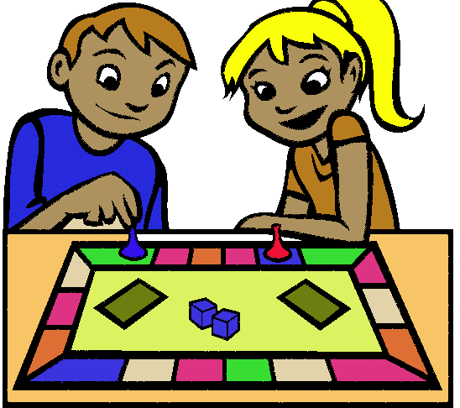
It’s important to remember that we will all respond differently during this time: maybe you like to keep busy and want to schedule in a few activities every day, or maybe you want to just look through it for some ideas and inspiration. This list is yours to use as you like.
Social activities

- Watch a movie with your family
- Have a ‘sleepover’ with sibling(s)
- Using Party Chat with friends on PlayStation/Xbox
- Play games with friends & family on the House party App
- Ask family members to show you how to do a skill: e.g. cooking, DIY, crafts
- FaceTime friends, or use Zoom and Skype for group conversations
- Play a game with someone in your house
- Make up a quiz to play with your family; or friends on House Party or WhatsApp
- See how many people you can get in a House Party chat at one time

Physical activities
- Try out yoga with Adriene, lessons for adults and kids. https://www.youtube.com/yogawithadriene
- Or join a live yoga session with people around the world. For example with LV Yoga https://lvyoga.co.uk/

- Join a live dance class, e.g. join live at 12pm and 6pm with 305 fitness https://www.youtube.com/305Fitness. Or learn the full dance routine to your favourite song with ‘Seen On Screen’, for dancers of all levels. Follow live-stream tutorials on instagram https://www.instagram.com/schoolofsos/?hl=en, or on zoom.
- Join Joe Wicks PE sessions at 9AM every morning on You Tube https://www.youtube.com/channel/UCAxW1XT0iEJo0TYlRfn6rYQ
- If possible go for a run, cycle or walk outside
- Run up and down the stairs, or see how many kick ups you can do
- Learn how to juggle/do a handstand (in the garden or in a safe room!)

- See how many star jumps/press ups or press ups you can do in a minute - or see how fast you can run on the spot in a minute
- The floor is lava
- Learn some Ballroom, Cha Cha and Bachata dancing - https://www.facebook.com/StepByStepDanceOnline/

Achievement activities
- Cook your favourite TV dish: ever wondered what Sponge Bob’s ‘Krabby Supreme’ would be like in real life? Or Ross’s ‘moist maker’ sandwich on Friends? Go to ‘Binging with Babish’ on YouTube to recreate recipes from TV and film https://www.bingingwithbabish.com/

- Make a movie at BrainPOP.com, or BrainPOP also provide free interactive lessons to help young people stay informed on the subjects they’ve always been curious about such as tech or social issues. https://www.brainpop.com/
- For younger children, Scholastic has loads of free resources and home learning packs to learn more about the world and things that interest them https://shop.scholastic.co.uk/homelearning
- Learn a new culinary skill e.g learn to make your favourite meal
- Redesign your bedroom / paint furniture / upcycle a piece of furniture
- Learn a new skill, such as phone photography, calligraphy or digital illustration: Brit+Co and Skillshare have both made online courses available for free https://www.brit.co/
https://www.skillshare.com/?utm_source=Blog&utm_medium=organicbrand&utm_campaign=HomePage&utm_content=708
- Learn British Sign Language: British sign are offering discounted (currently £3) lessons https://www.british-sign.co.uk/learn-online-british-sign-language-course/
- Learn a new language, for example with DuoLingo
- Work your way through your ultimate book list
- Start writing short stories
- Do a daily creative challenge from international artists http://dothinkshare.com/creative-inspiration/create-to-connect/
- Help someone with cleaning or chores
- Journaling or start writing a diary for your future self to look back on
- Plant seeds/ do some gardening/pot plants indoors
- Teach your pet a new trick
- Do some school work
- Kids Cookalong with Theo every Monday, Wednesday and Friday at 4pm http://www.theocooks.com/kids-cookalong-live/
- Make a TikTok video
- Making a little toolbox of activities/ and things you can do for yourself and for others.
- Make a timetable you can stick to during the day
- Draw yourself/people in your family in different ways - e.g. without lifting your pen from the paper; without looking at the paper; drawing from memory;

- Make a collage/scrapbook using old magazines or newspapers

Enjoyable activities
- Listen to a story: ‘Audible’ – has lots of free stories and children’s books which can be streamed from a laptop or smartphone
- Choose a story from the big list of Children’s Authors doing online read alouds https://www.weareteachers.com/
- Or snuggle down and read a book yourself.
- You could even make a mini book-club with friends or family where you choose a book to read and discuss it each week.
- Listen to a podcast
- Watch an interactive virtual tour of Disney World https://www.visitorlando.com/en/things-to-do/virtual-tours/walt-disney-world-resort
- Or a virtual tour of museums around the world https://britishmuseum.withgoogle.com/ https://www.timeout.com/travel/coronavirus-virtual-museum-tours
- Watch theatre productions live- for example go to @hampstead_theatre on instagram and click on the IGTV logo to start watching, or stream national theatre productions from home https://www.nationaltheatre.org.uk/nt-at-home?queueittoken=e_safetyevent25mar20~q_6ed81386-399a-49fc-915d-f4633ca0f0c6~ts_1585657599~ce_true~rt_safetynet~h_406f031fba88c31310a26853310a425557e675dc7c10b41ae6f8df0898d3e270
- If you like dance, Sadler’s Wells is screening archive performances, special one-offs created just for the screen and dance workshops aimed at a variety of ages. This kicks off on Friday 27th March at 7:30pm. Available via the streaming platform Digital Stage – go to www.sadlerswells.com for more information.
- Watch festival of performances that have been cancelled due to coronavirus https://www.socialdistancingfestival.com/ or https://cosmicshambles.com/stayathome
- View art galleries with online installations: https://www.serpentinegalleries.org/
- https://www.whitechapelgallery.org/ https://xmuseum.org/
- Follow ‘Time Out London’ on Instagram – each day they will tell you of events or things you can join in on that day e.g. quizzes, bingo, making pasta etc.

- Watching back previous matches of your favourite sport team
- Do a pamper evening with face masks, candles and a bubble bath.
- Schedule in some Netflix time
- Listen to music
- Get creative: do a short activity page with artist/illustrator Adam JK. https://shop.adamjk.com/collections/activity-pages/products/activity-pages
- Write a letter to a friend
- Do some mindfulness colouring with mindfulness colouring books or painting with numbers
- Play an instrument

