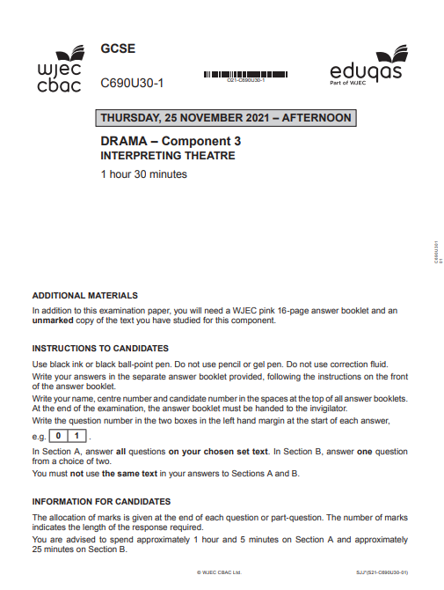

**FRIDAY 23RD FEBURARY 2024- MOCK EXAM- AFTERNOON**

**Sephy**

**Meggie**

**Meggie**

**Callum**

MEGGIE: “I cant understand it, Lynny hasn’t been outside in over a year!”

**Page 33: *MEGGIE and RYAN are arguing at the table***

**Page 36: CALLUM *rips up the letter***

CALLUM *is holding the letter from* LYNETTE. *He hesitates and opens it.*

**NOUGHTS AND CROSSES BY MALORIE BLACKMAN, ADAPTED BY SABRINA MAHFOUZ**

