**Paper 3: Philosophy & Ethics**

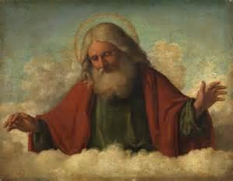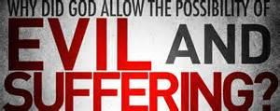**Arguments for and Against the Existence of God**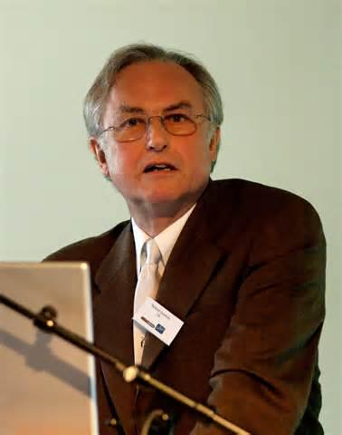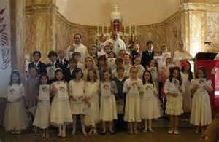

|  |  |
| --- | --- |
| **Keywords** | |
| Agnostic | A person who does not believe it is possible to know whether God exists or not. |
| Apparitions | Visionary experiences that have a physical effect on people around the visionary. |
| Auditory vision | A vision which is only a voice with no images. |
| Auschwitz | A Nazi Second World War concentration camp in Poland where at least 1.1 million Jews died. |
| Awe | A sense of overwhelming wonder at the vastness, mystery or beauty of something. |
| Beatified | The second stage is being declared a saint, the declaration that a deceased person is counted amongst the blesssed. |
| Big Bang | The beginning of the universe from a cosmic egg. |
| Blessed Sacrament Procession | the consecrated host is carried through the streets in a monstrance (special container for the Blessed Sacrament) |
| Canonised | A person who is declared a saint by the Church. |
| Contingent | The fact that something does not have to exist, it could either be or not be. |
| Causation | The scientific belief that everything in the universe has a cause, something which brought |
| it into existence. |
| Conversion | An experience which changes a person’s life or religion. |
| Corporeal Vision | Where people physically see something/ someone. |
| Design | When things are connected and seem to have a purpose, for example the eye is designed for seeing. |
| Evolution | The idea that life forms change over time (humans have developed as single organisms.) |
| Exorcism | removal of evil spirits who have possessed a person. |
| Franciscan | A member of a relgious order that follows the teachings of Saint Francis of Assisi. |
| Free will | The idea that human beings are free to make their own choices. |
| Friar | A member of a religious order who does not own property and who either has to work or beg to earn a living. |
| General Revelation | God making himself known through ordinary human experiences to everyone. e.g natural world, holy books. |
| Holiness | The state of being very moral and spiritual. |
| Holocaust | The mass murder of Jews by the Nazis in the Second World War. |
| Imaginative Vision | Where people see something in their imagination or dreams. |
| Immaculate Conception | The Catholic belief that God preserved Mary from original sin from the moment she was conceived. |
| Intercessory Prayers | Prayers asking for God's help for other people. |
| Miracle | Something which seems to break a law of science and makes you think only God could have done it. |
| Moral evil | Suffering caused by the actions of humans. |
| Natural evil/suffering | Suffering which is caused by nature and has nothing to do with humans. |
| Natural Revelation | The revealing of God in the nature of the Universe. |
| Nature Miracle | A miracle involving a change in natural objects or forces. |
| Omni-benevolent | The belief that God is all good. |
| Omnipotent | The belief that God is all-powerful. |
| Omniscient | The belief that God knows everything that has happened and everything that is going to happen. |
| Prime Mover: | the first mover or first causer of all other moving things. |
| Psalms | A book of the Old Testament containing 150 sacred writings. |
| Regenerative experience | A conversion experience giving the feeling of being born again. |
| Revelation | It means ‘uncovering’- something which was previously hidden becomes known. |
| Special Revelation | The revealing of God in in such things as holy books for example of Bible. VW |
| Special Revelation | "God makes himself known through direct personal experience. e.g miracles and dreams. |
| Spiritual | The non-material element of life, such as religion, feelings and values. |
| Summa Theologica | St. Thomas Aquinas' major book written 1265 - 74. |
| Theodicy | A philosophical justification of God allowing evil and suffering. |
| Transcendent | “The beyond” that which is more than the physical. |
| Vale of soul making | The idea that God gave people this life to make their souls good enough for heaven. |
| Vision | An experience of seeing someone or something in a dream or trance, as a supernatural apparition, or religious ecstasy which gives a religious message. |

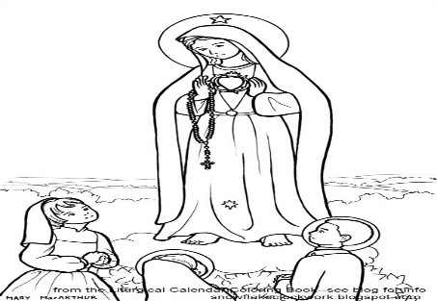

**1.1 Revelation**

**Learning Outcomes:**

By the end of this topic you should be able to:

* Know and understand how revelation can be proof of the existence of God​
* Assess and analyse what revelation shows about the nature of God

**STARTER:**

What does the word **reveal** mean?​

How might this be used in a religious context?

**TASK 1**

Fill in the gaps in the diagram below using the words provided. There are more words than gaps, you will need to decide which words to leave out.

God first _________ himself to people like Moses in the Old Testament

Catholics believe that today, through the _______ and the _________ _________, people can encounter Jesus and therefore God.

Catholics believe Jesus is the final ­­­­________; he was ________ in human form.

**JESUS**

__________ is proof to Christians of the existence of God.

**TASK 2** Read through the information sheets and fill in the table below.

|  |  |
| --- | --- |
| Natural Revelation | Special Revelation |
|  |  |
| The Significance of Jesus Christ as the culmination of revelation | What does revelation in Jesus Christ show Catholics about God’s nature? |
|  |  |

|  |
| --- |
| Key sources of wisdom and authority for this topic: |

**Exam practice**

**a)** Outline three things that the revelation of Jesus shows about God (3)

**b)** Explain two reasons why Catholics believe Jesus is the culmination of God’s revelation. (4)

**1.2 Visions**

**Learning Outcomes:**

By the end of this topic you should be able to:

* Know and understand how revelation can be proof of the existence of God
* Assess and analyse what revelation shows about the nature of God

**STARTER** Without looking at your keywords sheet, what do these keywords mean?

APPARITION:

VISION:

AUDITORY VISTION:

**TASK 1** Underneath each passage summarise what is happening and what type of vision it shows. Further information is on pages 298-299 of the textbook.

**Genesis 15:1**

**1**After this, the word of the Lord came to Abram in a vision:

“Do not be afraid, Abram.  
    I am your shield,  
    your very great reward.”

**Matthew 17:5**

**5**While he was still speaking, a bright cloud covered them, and a voice from the cloud said, “This is my Son, whom I love; with him I am well pleased. Listen to him!”

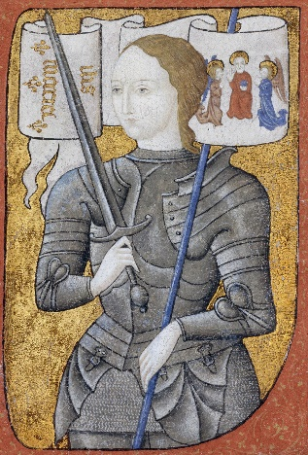

**TASK 2** Read through the information on page 300 of the textbook about Joan of Arc. Answer the following questions:

1. Who was Joan of Arc?
2. What type of vision did she have?
3. What happened in her vision?
4. Why do Catholics accept these visions?

**TASK 3** Complete the table with reasons for and against visions as proof of God’s existence.

|  |  |
| --- | --- |
| **Reasons why visions might lead people to believe in God** | **Reasons against visions as proof that God exists** |
|  |  |

|  |
| --- |
| Key sources of wisdom and authority for this topic: |

**Exam questions:**

1. Outline three visions that are important to Catholics
2. Explain two reasons why Catholics believe visions are important

d) ‘Visions prove that God exists.’ Evaluate this statement considering arguments for and against. In your response you must – refer to Catholic beliefs – refer to non-religious beliefs – reach a justified conclusion

**1.3 Miracles**

**Learning Outcomes:**

By the end of this topic you should be able to:

* Know and understand the nature and importance of miracles
* Know how Catholics respond to non-religious arguments against miracles
* Assess the importance of miracles for Catholics

**STARTER**

* A miracle is something that seems to break the laws of science and makes people think that only God could have done it.
* They involve a religious experience of some kind.
* The term miracle is often used colloquially. Do you think the following are miracles? Explain your answer:
* The birth of a baby
* A near miss traffic accident
* Finding a lost £20 note
* Not getting any RE homework!

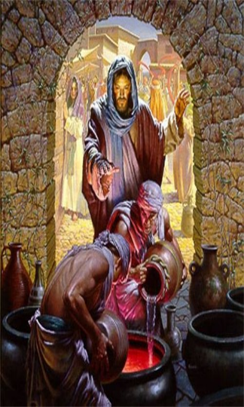**TASK 1**

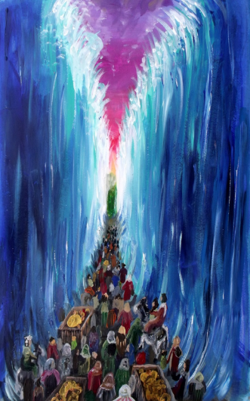

These images show two **biblical miracles**. What are they?

Now read the information on page 303-304 of the textbook and make notes about Lourdes. Then, research Guadalupe.

**Lourdes:**

**Our Lady of Guadalupe:**

**TASK 2** Use pages 304-305 to fill in the table below.

|  |  |
| --- | --- |
| **Reasons why miracles might lead people to believe in God** | **Reasons against miracles as proof that God exists** |
|  |  |

|  |
| --- |
| Key sources of wisdom and authority for this topic: |

**Exam questions**

a) Outline three miracles

b) Explain two reasons why a miracle may lead someone to believe in God

d) ‘Miracles prove that God exists’. Evaluate this statement considering arguments for and against. In your response you must – refer to Catholic beliefs – refer to non-religious beliefs – reach a justified conclusion

**1.4 Religious Experience**

**Learning Outcomes:**

By the end of this topic you should be able to:

* Know and understand Catholic attitudes to religious experiences
* Know and understand why not all religious experiences are approved by the Church
* Assess Catholic responses to non-religious arguments that religious experiences do not provide proof that God exists

**STARTER** Without looking at your keywords sheet, what do these keywords mean?

CONVERSION –

NUMINOUS –

TRANSCENDENT –

**TASK 1** Use pages 306-307 to fill in these boxes

**Numinous experience**

What is it?

Give an example of this experience:

Arguments against this religious experience:

**Conversion**

What is it?

Give an example of this experience:

Arguments against this religious experience:

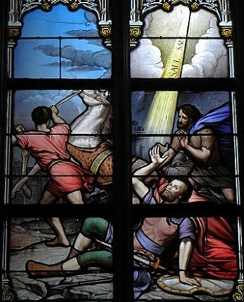

**Prayer**

What is it?

Give an example of this experience:

Arguments against this religious experience:

**TASK 2** Are these statements true or false?

1. For Catholics, a religious experience does not need to feature the presence of God.
2. Numinous means having a mysterious, spirit, or holy quality.
3. Transcendence means something within human experience.
4. Jesus is the final and complete revelation for Catholics.
5. The Catechism totally rules out any private revelations.

**EXT: Can you correct the false statements?**

|  |
| --- |
| Key sources of wisdom and authority for this topic: |

**Exam questions**

a) Outline three reasons some people do not think religious experience is proof for God’s existence.

b) Explain two ways Catholics respond to non-religious arguments about religious experience.

**1.5 The Design Argument**

**Learning Outcomes:**

By the end of this topic you should be able to:

* Know and understand the Design argument as proof for the existence of God
* Analyse the Catholic response to non-religious arguments against the design argument and the existence of God



**STARTER** Look at your pen.

How do you know it had a designer?

It is a work of nature? Give a reason.

**The design argument in summary:**

* **There appears to be design in the world**
* **If there is design, it implies a designer**
* **This designer must be God**

**TASK 1** If you can, watch this video: <https://www.youtube.com/watch?v=foeM6vXZCys> If you can’t watch the video the information is also on pages 310-313 of the textbook.

Read through page 311.

Summarise William Paley’s classic design argument:

Summarise modern forms of the design argument:

Why is the design argument important for Catholic beliefs about the nature of God?



**TASK 2** If you can, watch this video: <https://www.youtube.com/watch?v=9NGj6Zk9Wj0> then use page 313 to fill in the table.

|  |  |
| --- | --- |
| **Atheist and Humanist rejection of the design argument** | **Catholic responses** |
|  |  |

|  |
| --- |
| Key sources of wisdom and authority for this topic: |

**Exam Questions**

a) Outline three things the design argument shows about the nature of God for Catholics

d) ‘The design argument proves the existence of God.’ Evaluate this statement considering arguments for and against. In your response you should:

* refer to Catholic teachings
* refer to non-religious points of view
* reach a justified conclusion

**1.6 The Cosmological Argument**

**Learning Outcomes:**

By the end of this topic you should be able to:

* Know and understand the Cosmological argument for proof of the existence of God
* Know and understand what the Cosmological argument teaches about the nature of God
* Assess and analyse Catholic responses to non-religious arguments against the Cosmological argument as evidence for the existence of God

**STARTER**

|  |
| --- |
| What made the dominoes fall? |



**The cosmological argument summarised:**

* **Put forward by St Thomas Aquinas**
* **There is cause and effect in the world**
* **There must be a first cause**
* **The first cause must be God**

**TASK 1** If you can, watch this video: <https://www.youtube.com/watch?v=yyiNbJlqcJo>

Explain Aquinas’ three ways to prove God’s existence (page 314)

Way 1 –

Way 2 –

Way 3 –

**TASK 2** Watch this video: <https://www.youtube.com/watch?v=WLKwImYuEKU>

Use page 315 to fill in the table below.

|  |  |
| --- | --- |
| **Atheist and Humanist arguments against the cosmological argument** | **Catholic responses** |
|  |  |

|  |
| --- |
| Key sources of wisdom and authority for this topic: |

**Exam Questions**

c) Explain two reasons why Catholics believe the cosmological argument proves the existence of God. In your answer you must refer to a source of wisdom and authority.

d) ‘The cosmological argument proves the existence of God.’ Evaluate this statement considering arguments for and against. In your response you should:

* refer to Catholic teachings
* refer to non-religious points of view
* reach a justified conclusion

**1.7 The Problem of Evil and Suffering**

**Learning Outcomes:**

By the end of this topic you should be able to:

* Know and understand the problem of evil and a loving and righteous God and the nature of natural and moral evil
* Know and understand the problems it raises for Catholics about the nature of God
* Analyse and assess the reasons why the problem of evil might cause some believers to question their faith

**STARTER** Without looking at your keywords sheet, what do these keywords mean?

OMNIPOTENT –

OMNISCIENT –

OMNI-BENEVOLENT –

MORAL EVIL –

NATURAL SUFFERING –

**TASK 1**

Catholics believe that there is only one God who reveals himself as a Trinity. All theists, Catholics included believe God is all powerful, has all knowledge, is extremely good and is everywhere at once.

Complete the table, explaining how each characteristic God is believed to have leads to problems for Catholics. The image below and page 318 of your textbook will help.

|  |  |
| --- | --- |
| **Characteristic of God** | **How this leads to a problem for believers** |
| Omnipotent |  |
| Omniscient |  |
| Omnibenevolent |  |

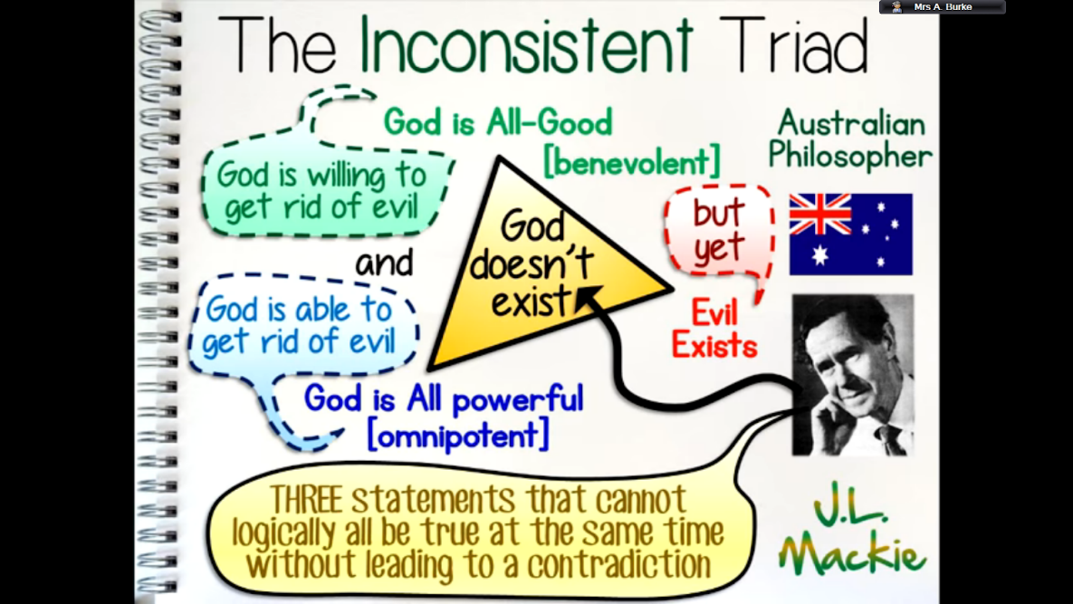

**TASK 2** Why does the problem of evil and suffering lead some Christians to examine or reject their belief in God? (page 319)



|  |
| --- |
| Key sources of wisdom and authority for this topic: |

**Exam questions**

a) Outline the characteristics of God

**1.8 Solutions to the Problem of Evil and Suffering**

**Learning Outcomes:**

By the end of this topic you should be able to:

* Know and understand Catholic solutions to the problem of evil and suffering and a loving God
* Know and understand the biblical, theoretical and practical solutions that been  suggested to the problem
* Assess and analyse how successful the various solutions are

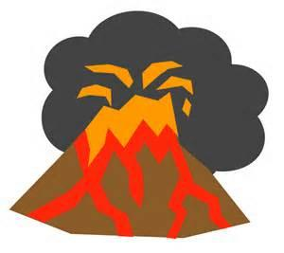**STARTER** Quick recap!

Why might things such as hurricanes, earthquakes and volcanoes make people doubt God’s existence?



Why might things such as people suffering from dreadful diseases make people doubt God’s existence?

**TASK 1** Use pages 320-322 to fill in the table with information about biblical, theoretical and practical responses to evil and suffering

|  |  |  |
| --- | --- | --- |
| **Biblical** | **Theoretical** | **Practical** |
|  |  |  |

**TASK 2** Answer the following questions

1. Which two solutions do you think are the most successful? Explain why you chose them.

2. Which two solutions do you think are the least successful? Explain why you chose them.

|  |
| --- |
| Key sources of wisdom and authority for this topic: |

**Exam questions**

a) Outline three Catholic responses to the problem of evil and suffering.

d) “The problem of suffering makes it hard to believe in God.” Evaluate this statement considering arguments for and against. In your response you should:

• refer to Catholic teachings

• reach a justified conclusion.